Use-Case-Model Survey for vmcs

Issue 2.0
Revision History
Date | Issue | Description | Author
12 July 2000 | 1.0 | First Issue | Howard Russon
17 July 2001 | 2.0 | Revised for MTech Unit 3 in 2001 | Howard Russon

Table of Contents
1. Introduction 4
2. Survey Description 4
2.1 System Set-Up 4
2.2 Customer Operations 4
2.3 Maintenance Operations 4
3. Actors 5
3.1 Controller 5
3.2 Customer 5
3.3 Maintainer 5
4. Use Cases 5
4.1 Change State 5
4.2 Coin Input and Select Brand 5
4.3 Dispense Drink 5
4.4 Give Change 5
4.5 Refund Money 5
4.6 Set-Up Panels 5
4.7 System Maintenance 6
4.8 System Start-Up & Close-Down 6
4.9 Transfer All Cash 6
5. Views 7

Use-Case-Model Survey for vmcs

Introduction
The Vimto Soft Drinks Company operates and maintains a large number of automatic soft drinks dispensers (vending machines) at various sites throughout Singapore. Vimto requires a computerised control system for their new range of vending machines. For this part of the project, the system is to be designed and implemented as a computer simulation of a vending machine. The main requirements for the system are defined in "User Requirements Specification for the Vending Machine Control System (VMCS) Computer Simulation", reference ISS/VMCS/TR.1/1. The system is to be developed using object-oriented techniques and the Java programming language.

The highest level of object oriented analysis involves describing the requirements in terms of Use Case. The aim of the Use Case Model is to provide an overview of these use cases and their users (known as Actors).

Survey Description
The main users of the vending machine are the:

- The Customer who enters Coins, selects a Drinks Brand, and collects a drinks-can from the machine.

- The Maintainer who monitors the stock levels of cans of each Drinks Brand and Change, and replenishes or removes stock when necessary.

In the VMCS computer simulation, which this project principally addresses, it is not possible to interface with the actual vending machine and its sensors. Hence the user panels of the vending machine, and the physical actions of the Maintainer have to be simulated. The main device chosen to achieve this is through an actor, referred to as the Controller. The sequence of the use cases which are typically performed in the system are described in the following subsections.

System Set-Up
The controller has the responsibility to set-up the user interface so that the system can be used by the other actors as follows:

  - The use case System Start-up & Close-Down provides the Simulator Control Panel from which the system can formally be switched on or off, and from which each of the other user panels can be activated and displayed.
  - When the system simulation is started, the use case Set-Up panels is used to set-up the panels. This use case determines the drinks and cash stocks in the machine and displays them appropriately.

Customer Operations
The functions that the Customer can perform with the vending machine user interface (Customer Panel) are undertaken through the use case Coin Input and Select Brand. This uses separate abstract use cases to handle its main interactions with the hardware elements of the vending machine. That is, it uses the following use cases:

- Dispense Drink;
- Give Change; and
- Refund Money.

Maintenance Operations
The functions required to maintain stocks of drinks cans and change in the vending machine are carried out by two actors: the Maintainer, who performs user interface operations which will be provided in the real vending machine; the Controller who performs simulated functions which will not be computerised in the real machine.

The Maintainer's functions are provided through the use case System Maintenance. The Maintainer works in collaboration with the Controller and use case Change State as follows:

- Using the Maintenance Panel, the Maintainer can review stock levels.
- This also uses use case Transfer All Cash to enable the Maintainer to collect all the cash inside the vending machine.
- Using the Machinery Simulator Panel, the Controller can now change (add/remove) stocks.
- When the Maintainer/Controller have completed their tasks, the Customer Panel displays are update.

Actors

Controller
Documentation: This actor represents the controller of the VMCS simulation. Hence it is only present in the simulated system (ie: this project) and would not be an actor of the target implementation. In particular, it performs several of the physical activities (ie: those that can not be provided by software) that are undertaken by the Maintainer in the target implementation, which include maintaining drink stocks and cash stocks inside the vending machine.

Customer
Documentation: This actor represents the customer of the vending machine (members of the general public) who would buy drinks-cans from the vending machine.

Maintainer
Documentation: This actor represents the vending machine maintainer who will have a simple display panel to enable stock levels of drinks-cans and change to be monitored, and to enable cash within the machine to be collected.

Use Cases

Change State
Documentation: This use case enables the Controller to perform the physical activities that the Maintainer would perform in the target implementation. Using the Machinery Simulator Panel, the Controller will be able to change the stock level for each brand or coin denomination, and to lock the vending machine door.

Coin Input and Select Brand
Documentation: This use case enables the Customer to buy drinks from the vending machine by selecting a brand from those available, and then entering coins to pay for the selection. Invalid coins will be returned. Provided the required amount of money is entered, the selected brand will be dispensed to the customer. Change will be given if more money than the price of the drink is entered. The Customer will be permitted to terminate the purchase prior to the selected brand being dispensed. In such cases, the money entered will be refunded.

Dispense Drink
Documentation: This abstract use case enables the selected brand to be dispensed to the Customer.

Give Change
Documentation: This abstract use case enables change to be issued to the Customer.

Refund Money
Documentation: This abstract use case enables refunds of the money entered to be issued to the Customer.

Set-Up Panels
Documentation: This use case enables the Controller to use the Simulation Control Panel to display the three main user interface panels of the vending machine simulation: the Customer Panel, the Maintenance Panel and the Machinery Simulator Panel.

System Maintenance
Documentation: The use case enables the Maintainer to perform vending machine maintenance tasks. The Maintainer will be able to monitor the stock levels of brands and coin denominations, view/change the prices of brands and remove all the coins from the vending machine.

System Start-Up & Close-Down
Documentation: This use case enables the Controller to start-up and close-down the computer simulation of the vending machine. This involves displaying a Simulation Control Panel (when the application is launched). Using the panel, the Controller will be able to start-up the simulation or exit from the application.

Transfer All Cash
Documentation: This abstract use case enables all the coins in the vending machine to be issued to the Maintainer.

Views
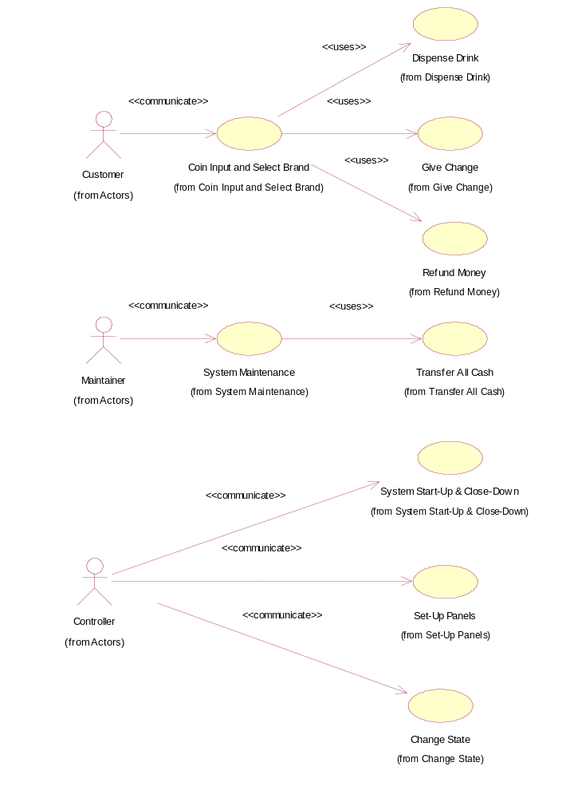
Use-Case Diagram: Global View of Actors and Use Cases

